To the Editorial Board,

We are pleased to submit a revised version of our manuscript for consideration. We have updated our manuscript based on the thoughtful reviews provided. You will find a response to reviews as well as our updated manuscript.

On behalf of my co-authors,

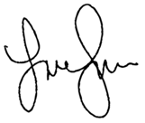

Lauren Sullivan
Michigan State University (LLSULL@msu.edu)

